**Topic:** Diophantus, Khawarizmi, Bhaskara

**Notes on Topic:**

**Diophantus (early 200s):** Known as the father of algebra, born in Alexandria, another scholar of the great library

Known for his publishing called *Arithmetica*, which is a collection of 130 giving solutions for determinate and indeterminate equations

He only examines solutions that were positive and rational, negative and irrational solutions, Diophantus deemed useless

Diophantus examined three types of quadratic equations,

$ax^{2}+bx=c$

$ax^{2}=bx+c$

$ax^{2}+c=bx$

In this time there was no notation for zero, and Diophantus did not deal with negative coefficients.

Diophantus also solved problems such as,

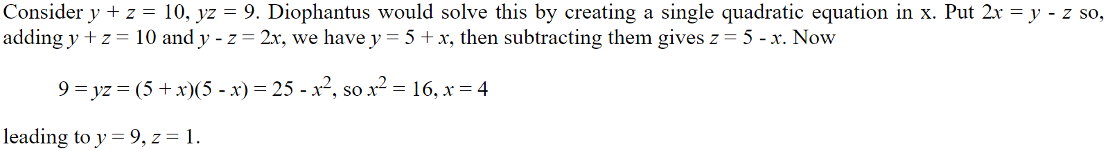

Though Diophantus did not use sophisticated algebraic symbolism, he did invent the use of a symbol for the unknown quantity and the powers of the unknown. Therefore taking large steps toward symbolic algebra.

**Source:** <http://www-history.mcs.st-andrews.ac.uk/Biographies/Diophantus.html>

**Al - Khawarizmi (825 AD):** The library of Alexandria remained an intact place of scholarship through centuries  
It was originally closed by the Christians in 529 AD for its huge collection of pagan documents  
Then in 641 the library was ultimately burned by the Arabs   
The study of mathematics that had been centered at this library had then shifted to Arabian mathematics for centuries afterward   
  
As the Islamic empire rose with the life of Mohammed   
The religion had spread across India, Persia, the Middle East, Africa, Spain  
Islamic scholars assimilated the knowledge of many cultures that they came across   
Among this knowledge was the “Hindu-Arabic” number system   
“This system was so superior to that of the Romans that it has relegated the latter to clock faces, copyright dates, and Super Bowls”  
  
Around the 9th century the great scholar Tabit ibn Qorra translated the works of Archimedes, Apollonius, and a very faithful translation of the Elements  
The center of scholarship was The House of Wisdom in Baghdad -- becoming the center of the mathematical world, which would remain in Baghdad for a long time   
  
One of the most important mathematicians was al-Khowarizmi  
He borrowed from the East and the West, from Hindu mathematicians and Greek mathematics  
He produced a treatise on algebra and arithmetic   
He illustrated the solution to not only linear equations, but also quadratic and verbally provided the now important quadratic formula  
He is also accredited for giving algebra its name, his major treatise was titled, in latin, “*Ludus algebrae et almucgrabalaeque*” latered shortened to “algebra”  
His treatises were meant to be seen as not only texts of logic, he felt algebra was here to help solve practical problems  
He did not use symbols in his text, only written language (squares would stand for x^2, roots are x, etc)  
He first reduces an equation (linear or quadratic) to one of six standard forms:  
1. Squares equal to roots.  
2. Squares equal to numbers.  
3. Roots equal to numbers.  
4. Squares and roots equal to numbers; e.g. .  
5. Squares and numbers equal to roots; e.g. .  
6. Roots and numbers equal to squares; e.g. $3x+4=x^{2}$.  
The reduction is carried out using the two operations of al-jabr and al-muqabala. Here "al-jabr" means "completion" and is the process of removing negative terms from an equation. For example, using one of al-Khwarizmi's own examples, "al-jabr" transforms $x^{2}=40x-4x^{2}$ into $5x^{2}=40x$. The term "al-muqabala" means "balancing" and is the process of reducing positive terms of the same power when they occur on both sides of an equation. For example, two applications of "al-muqabala" reduces $50+3x+x^{2}=29+10x$ to $21+x^{2}=7x$ (one application to deal with the numbers and a second to deal with the roots).  
Al-Khwarizmi then shows how to solve the six standard types of equations. He uses both algebraic methods of solution and geometric methods. For example to solve the equation $x^{2}+10x=39$ he writes:  
  
*... a square and 10 roots are equal to 39 units. The question therefore in this type of equation is about as follows: what is the square which combined with ten of its roots will give a sum total of 39? The manner of solving this type of equation is to take one-half of the roots just mentioned. Now the roots in the problem before us are 10. Therefore take 5, which multiplied by itself gives 25, an amount which you add to 39 giving 64. Having taken then the square root of this which is 8, subtract from it half the roots, 5 leaving 3. The number three therefore represents one root of this square, which itself, of course is 9. Nine therefore gives the square.*  
  
He also described how to foil two linear equations together   
  
Gandz gives this opinion of al-Khwarizmi's algebra in S Gandz, The sources of al-Khwarizmi’s algebra, Osiris, i (1936), 263-77:  
*“Al-Khwarizmi's algebra is regarded as the foundation and cornerstone of the sciences. In a sense, al-Khwarizmi is more entitled to be called "the father of algebra" than Diophantus because al-Khwarizmi is the first to teach algebra in an elementary form and for its own sake, Diophantus is primarily concerned with the theory of numbers.”*

Arabian mathematics did not regard proof as being the heart of mathematics, so there are no Arabian great theorems here   
Arabian mathematics did provide a sound number system and contributed greatly to the problem of solving equations

**Activity** The geometric proof of completing the square from the problem above   
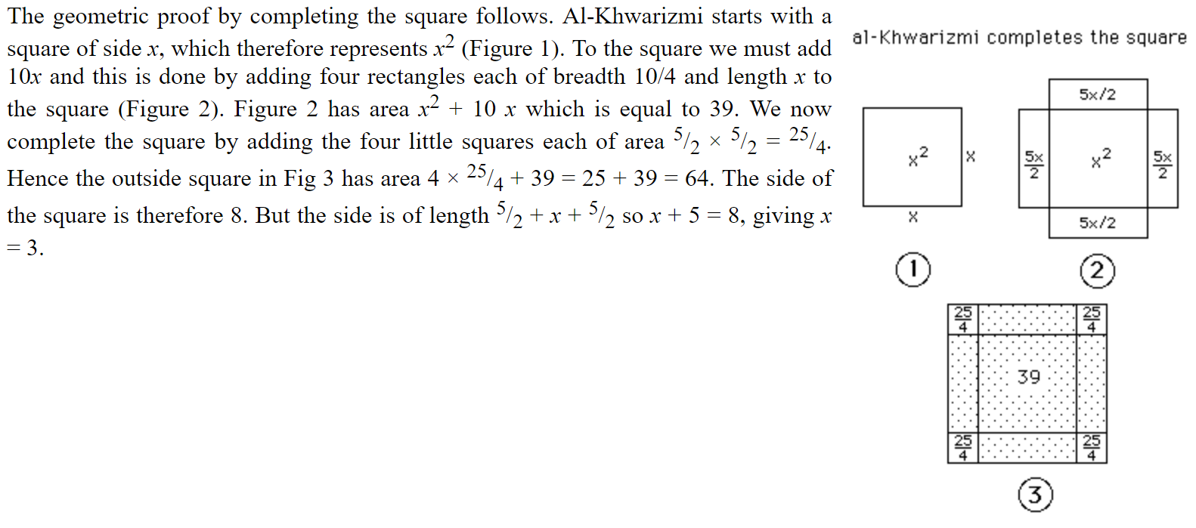

**Sources**: - JTG, Chapter 5 Epilogue

* <http://www-history.mcs.st-andrews.ac.uk/Biographies/Al-Khwarizmi.html>

**Bhaskara (12th Century):**

Bhaskara is representation of peak mathematics in the 12th century

He was aware of what negative numbers and zeros were. He was also aware that there are two solutions to squared values

“Six works by Bhaskaracharya are known but a seventh work, which is claimed to be by him, is thought by many historians to be a late forgery. The six works are: *Lilavati* (The Beautiful) which is on mathematics; *Bijaganita* (Seed Counting or Root Extraction) which is on algebra; the *Siddhantasiromani* which is in two parts, the first on mathematical astronomy with the second part on the sphere; the *Vasanabhasya* of *Mitaksara* which is Bhaskaracharya's own commentary on the *Siddhantasiromani* ; the *Karanakutuhala* (Calculation of Astronomical Wonders) or *Brahmatulya* which is a simplified version of the *Siddhantasiromani* ; and the *Vivarana* which is a commentary on the *Shishyadhividdhidatantra* of Lalla. It is the first three of these works which are the most interesting, certainly from the point of view of mathematics, and we will” concentrate on the contents of these.

He introduced two ways of multiplying in *Lilavati*:

Here is one example:

Start with,

243 243 243

325

----------------------------------



243 243 243

3 2 5

-------------------

1015

20

-------------------



243 243 243

3 2 5

-------------------

1015

20

-------------------

1215



243 243 243

3 2 5

-------------------

4 6 1015

8 20

-------------------

1215

486



243 243 243

3 2 5

-------------------

6 9 4 6 1015

12 8 20

-------------------

1215

486

729

-------------------



243 243 243

3 2 5

-------------------

6 9 4 6 1015

12 8 20

-------------------

1215

486

729

-------------------

78975

The *Bijaganita* is a work in twelve chapters. The topics are: positive and negative numbers; zero; the unknown; surds; the kuttaka; indeterminate quadratic equations; simple equations; quadratic equations; equations with more than one unknown; quadratic equations with more than one unknown; operations with products of several unknowns; and the author and his work.

He also discussed what it meant to divide by zero, in his works,

*A quantity divided by zero becomes a fraction the denominator of which is zero. This fraction is termed an infinite quantity. In this quantity consisting of that which has zero for its divisor, there is no alteration, though many may be inserted or extracted; as no change takes place in the infinite and immutable God when worlds are created or destroyed, though numerous orders of beings are absorbed or put forth.*

The *Siddhantasiromani* is a mathematical astronomy text similar in layout to many other Indian astronomy texts of this and earlier periods. The twelve chapters of the first part cover topics such as: mean longitudes of the planets; true longitudes of the planets; the three problems of diurnal rotation; syzygies; lunar eclipses; solar eclipses; latitudes of the planets; risings and settings; the moon's crescent; conjunctions of the planets with each other; conjunctions of the planets with the fixed stars; and the paths of the sun and moon.

**Source:** <http://www-history.mcs.st-andrews.ac.uk/Biographies/Bhaskara_II.html>

**Additional Suggested Reading**: Epilogue, Chapter 5

**Assignment:** Homework 4: one problem per pop-up mathematician